Mini Project Documentation

Developed By: KALAVA YAMINI KRISHNA

Project Title

Jwellery Store – E-Commerce Web Application

Project Overview

This mini project represents a responsive E-Commerce Website for an Jwellery Store, designed using HTML, CSS, and JavaScript. It includes category-wise pages for:
- Bangles
- Bracelets
- Choker
- Hip belts
- Ear rings
- Rings

Technologies Used

HTML5 – Web page structure CSS3 – Styling and layout JavaScript – Interactivity

ER Diagram

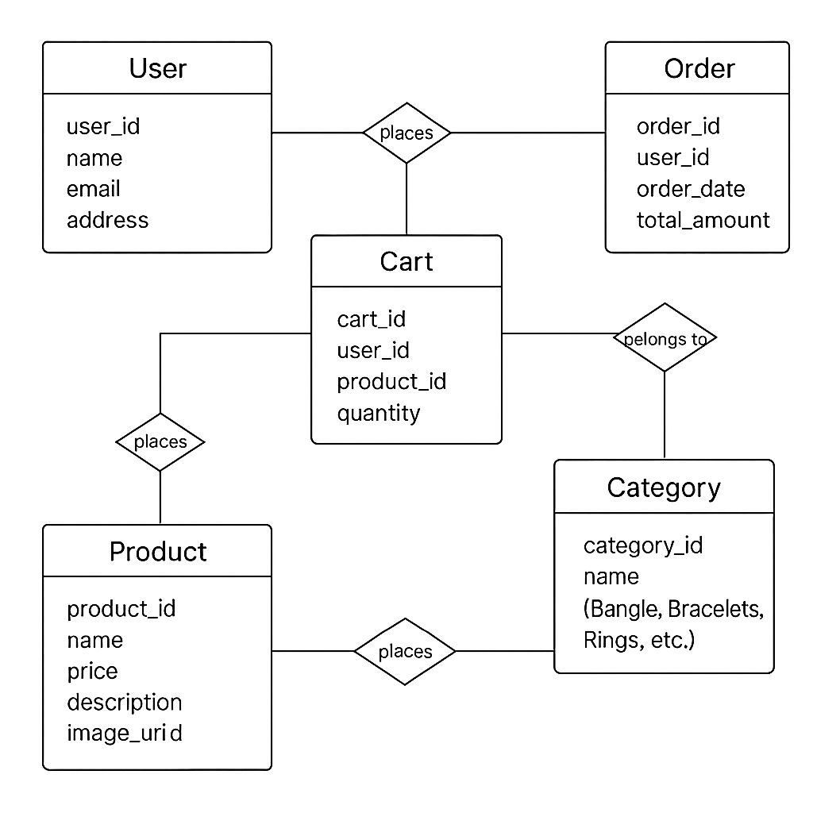
DB Code

-- USERS TABLE
CREATE TABLE users (
user_id INT AUTO_INCREMENT PRIMARY KEY,
name VARCHAR(100),
email VARCHAR(100) UNIQUE,
address TEXT
);

-- CATEGORIES TABLE (e.g., Bangles, Bracelets, etc.)
CREATE TABLE categories (
category_id INT AUTO_INCREMENT PRIMARY KEY,
name VARCHAR(50) -- Examples: Bangles, Bracelets, Rings, etc.
);

-- PRODUCTS TABLE
CREATE TABLE products (
product_id INT AUTO_INCREMENT PRIMARY KEY,
name VARCHAR(100),
price DECIMAL(10, 2),
description TEXT,
image_url VARCHAR(255),
category_id INT,
FOREIGN KEY (category_id) REFERENCES categories(category_id)
);

-- CART TABLE
CREATE TABLE cart (
cart_id INT AUTO_INCREMENT PRIMARY KEY,
user_id INT,
product_id INT,
quantity INT,
FOREIGN KEY (user_id) REFERENCES users(user_id),
FOREIGN KEY (product_id) REFERENCES products(product_id)
);

-- ORDERS TABLE
CREATE TABLE orders (
order_id INT AUTO_INCREMENT PRIMARY KEY,
user_id INT,
order_date DATETIME DEFAULT CURRENT_TIMESTAMP,
total_amount DECIMAL(10, 2),
FOREIGN KEY (user_id) REFERENCES users(user_id)
);

-- ORDER DETAILS TABLE (Many-to-many between orders and products)
CREATE TABLE order_details (
order_detail_id INT AUTO_INCREMENT PRIMARY KEY,
order_id INT,
product_id INT,
quantity INT,
price DECIMAL(10, 2),
FOREIGN KEY (order_id) REFERENCES orders(order_id),
FOREIGN KEY (product_id) REFERENCES products(product_id)
);
INSERT INTO categories (name) VALUES
('Bangles'),('Bracelets'),('Rings'),('Ear Rings'),('Hip Belts'),('Chokers');

Architecture Diagram
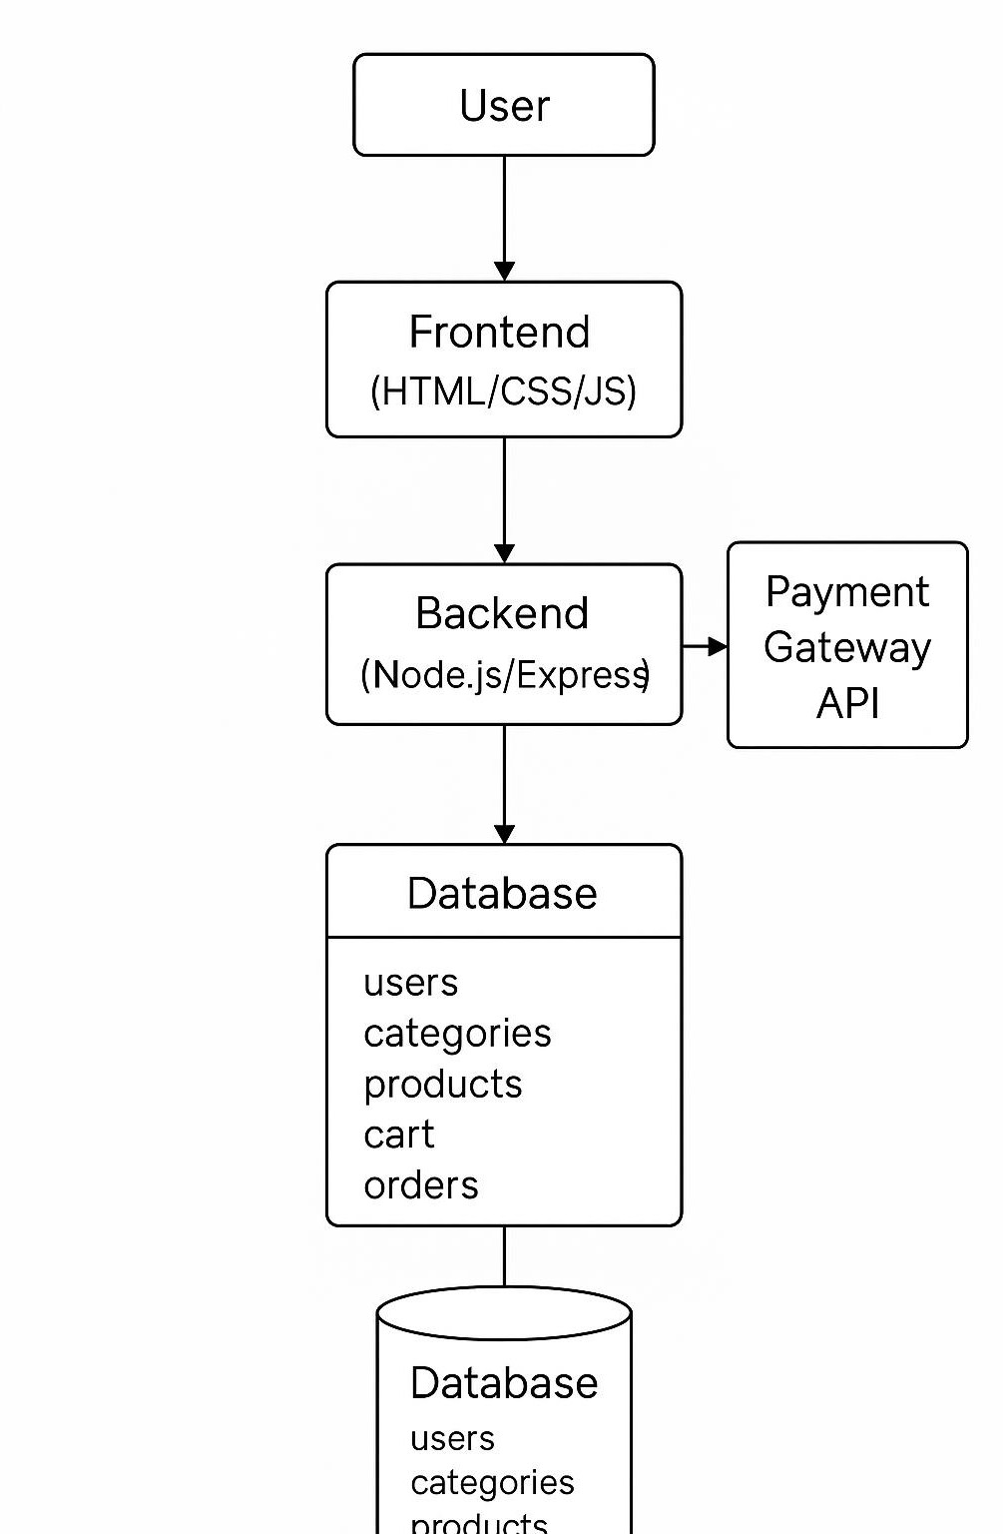

Folder Structure

/Jwellery-store/
├── index.html
├── fruits.html
├── Bangles.html
├── Belt.html
├── Bracelets.html
├── Choker.html
├── Ear rings.html
├── Rings.html

├── css/
│ ├── style.css
│ ├── Bangles .css
│ ├── Belt .css
│ ├── Braceletes.css
│ ├── Choker.css
│ ├── Ear rings.css
│ ├── Rings.css

├── js/
│ ├── script.js
│ ├── Bangles.js
│ ├── Belt.js
│ ├── Bracelets .js
│ ├── Choker .js
│ ├── Ear rings.js
│ └── Rings.js

└── assets/
├── images/
└── icons/

Page-Wise Code Explanation

Each category page (Bangles, Bracelets, etc.) includes:
- HTML page to list products
- CSS file for styling that section
- JavaScript file for cart actions

Index.html

<!DOCTYPE html>

<html lang="en">

<head>

<meta charset="UTF-8">

<title>Jewellery</title>

<!-- Bootstrap CSS for navbar and cards -->

<link href="https://cdn.jsdelivr.net/npm/bootstrap@5.3.0/dist/css/bootstrap.min.css" rel="stylesheet">

<link rel="stylesheet" href="style.css">

<style>

/* Blur effect for all bold text */

b, strong, .card-title {

color: #02a505 !important;

filter: blur(0.5px);

font-weight: bold;

}

</style>

</head>

<body>

<!-- Navbar -->

<nav class="navbar navbar-expand-lg navbar-dark bg-success">

<div class="container-fluid">

<a class="navbar-brand" href="#">Jewellery</a>

<div class="ms-auto d-flex gap-2">

<a href="login.html" class="btn btn-outline-light">Log In</a>

<a href="signin.html" class="btn btn-light">Sign Up</a>

</div>

</div>

</nav>

<div class="container mt-5">

<h1 class="text-center mb-4"><strong>Welcome to Our Jewellery Store</strong></h1>

<p class="text-center mb-5">Discover exquisite bangles, bracelets, rings, ear rings, hip belts, and chokers!</p>

<div class="row justify-content-center">

<!-- Bangles Card -->

<div class="col-md-4 mb-4">

<div class="card h-100 text-center">

<a href="bangles.html" style="text-decoration:none; color:inherit;">

<img src="D:\Black bucks\B.jpg"class="card-img-top" alt="Bangles" style="height:200px; object-fit:cover;">

<div class="card-body">

<h5 class="card-title">Bangles</h5>

<p class="card-text">Explore our elegant collection of bangles.</p>

</div>

</a>

</div>

</div>

<!-- Bracelet Card -->

<div class="col-md-4 mb-4">

<div class="card h-100 text-center">

<a href="bracelets.html" style="text-decoration:none; color:inherit;">

<img src="D:\Black bucks\bracelet 3.webp" class="card-img-top" alt="Bracelet" style="height:200px; object-fit:cover;">

<div class="card-body">

<h5 class="card-title">Bracelet</h5>

<p class="card-text">Find stylish bracelets for every occasion.</p>

</div>

</a>

</div>

</div>

<!-- Rings Card -->

<div class="col-md-4 mb-4">

<div class="card h-100 text-center">

<a href="rings.html" style="text-decoration:none; color:inherit;">

<img src="D:\Black bucks\Ring 1.jpg" class="card-img-top" alt="Rings" style="height:200px; object-fit:cover;">

<div class="card-body">

<h5 class="card-title">Rings</h5>

<p class="card-text">Browse our beautiful rings collection.</p>

</div>

</a>

</div>

</div>

<!-- Ear Rings Card -->

<div class="col-md-4 mb-4">

<div class="card h-100 text-center">

<a href="earrings.html" style="text-decoration:none; color:inherit;">

<img src="D:\Black bucks\Ear ring 3.jpg" class="card-img-top" alt="Ear Rings" style="height:200px; object-fit:cover;">

<div class="card-body">

<h5 class="card-title">Ear Rings</h5>

<p class="card-text">Discover dazzling ear rings for all styles.</p>

</div>

</a>

</div>

</div>

<!-- Hip Belts Card -->

<div class="col-md-4 mb-4">

<div class="card h-100 text-center">

<a href="hipbelts.html" style="text-decoration:none; color:inherit;">

<img src="D:\Black bucks\Belt 6.jpg" class="card-img-top" alt="Hip Belts" style="height:200px; object-fit:cover;">

<div class="card-body">

<h5 class="card-title">Hip Belts</h5>

<p class="card-text">Shop our unique and trendy hip belts.</p>

</div>

</a>

</div>

</div>

<!-- Choker Card -->

<div class="col-md-4 mb-4">

<div class="card h-100 text-center">

<a href="choker.html" style="text-decoration:none; color:inherit;">

<img src="D:\Black bucks\choker 6.webp" class="card-img-top" alt="Choker" style="height:200px; object-fit:cover;">

<div class="card-body">

<h5 class="card-title">Choker</h5>

<p class="card-text">Adorn yourself with our elegant chokers.</p>

</div>

</a>

</div>

</div>

</div>

</div>

Style.css
body {
font-family: Arial, sans-serif;
background: #f2fff0;
margin: 0;
padding: 0;
}
h1 {
text-align: center;
}
nav {
display: flex;
justify-content: center;
gap: 30px;
margin: 40px 0 20px 0;
}
nav a {
background: #4caf50;
color: #fff;
text-decoration: none;
padding: 14px 36px;
border-radius: 6px;
font-size: 20px;
transition: background 0.2s;
}
nav a:hover {
background: #388e3c;
}
.logout-btn {
display: inline-block;
margin: 20px auto;
background: #f44336;
padding: 10px 24px;
color: #fff;
border-radius: 4px;
text-decoration: none;
}
.welcome-container {
max-width: 600px;
margin: 70px auto;
padding: 40px;
background: #fff;
border-radius: 10px;
text-align: center;
box-shadow: 0 2px 16px #e0e0e0;
}
.login-container {
max-width: 400px;
margin: 100px auto;
padding: 36px;
background: #fff;
border-radius: 10px;
text-align: center;
box-shadow: 0 2px 16px #e0e0e0;
}
.login-container input[type="text"], .login-container input[type="password"] {
width: 80%;
padding: 10px;
margin: 10px 0 20px 0;
border: 1px solid #ccc;
border-radius: 4px;
}
.login-container button {
padding: 10px 24px;
font-size: 16px;
border: none;
background: #45b649;
color: #fff;
border-radius: 4px;
cursor: pointer;
}
#loginMsg {
color: #f44336;
margin-top: 15px;
}
.total {
text-align: center;
margin: 30px 0;
}
button {
padding: 10px 24px;
font-size: 16px;
border: none;
background: #45b649;
color: #fff;
border-radius: 4px;
cursor: pointer;
}
a {
display: block;
text-align: center;
margin-top: 20px;
}
.card {
border-radius: 12px;
box-shadow: 0 2px 12px #e0e0e0;
transition: transform 0.2s, box-shadow 0.2s;
border: none;
}
.card:hover {
transform: translateY(-6px) scale(1.03);
box-shadow: 0 6px 24px #b2dfdb;
}
.card-img-top {
border-top-left-radius: 12px;
border-top-right-radius: 12px;
width: 220px; /* Changed width */
height: 220px; /* Changed height */
object-fit: cover;
margin: 24px auto 0 auto;
display: block;
}
.card-title {
font-size: 1.4rem;
letter-spacing: 1px;
color: #02a505 !important;
filter: blur(0.5px);
font-weight: bold;
}
.card-text {
color: #555;
}

Main.js
document.addEventListener('DOMContentLoaded', function() { const form = document.getElementById('loginForm');
if(form) {
form.addEventListener('submit', function(e) { e.preventDefault();
// Simple demo login: any non-empty fields
const user = document.getElementById('username').value.trim(); const pwd = document.getElementById('password').value.trim(); const msg = document.getElementById('loginMsg');
if(user && pwd) { window.location.href = "index.html";
} else {
msg.textContent = "Please enter both username and password.";
}
});
}
});

Bangles.html / Bangles.css / Bangles.js
- Displays Different Types of Bangles.
- Products have images, names, prices, and Add to Cart buttons

Bangles.html
<!DOCTYPE html>
<html lang="en">
<head>
<meta charset="UTF-8">
<title>Bangles| Jewellery Store</title>
<link rel="stylesheet" href="Bangles.css">
</head>
<body>
<h1>Bangles</h1>
<div class="store" id="Bangles"></div>
<div class="total">
<button onclick="calculateTotal()">Calculate Total</button>
<p id="totalPrice">Total: ₹0.00</p>
</div>
<a href="index.html">Back to Home</a>
<script src="Bangles.js"></script>
</body>
</html>

Bangles.css
.store {
display: flex;
flex-direction: row;
flex-wrap: wrap;
gap: 24px;
justify-content: center;
margin-bottom: 24px;
}
.bangle-row {
display: flex;
justify-content: space-between;
align-items: center;
border: 1px solid #ddd;
border-radius: 8px;
padding: 12px 16px;
background: #fafafa;
}
.bangle-name {
font-size: 1.1rem;
font-weight: 500;
}
.add-btn {
background: #198754;
color: #fff;
border: none;
border-radius: 4px;
padding: 6px 18px;
font-size: 1rem;
cursor: pointer;
transition: background 0.2s;
}
.add-btn:hover {
background: #145c32;
}
.total {
text-align: center;
margin-bottom: 24px;
}
h1 {
text-align: center;
color: #d04646;
}

Bangles.js
const bangles = [
{
name: "Bangle 1",
price: 120,
image: "D:/Black bucks/Bangles 7.jpg"
},
{
name: "Bangle 2",
price: 150,
image: "D:/Black bucks/Bangles 8.webp"
},
{
name: "Bangle 3",
price: 180,
image: "D:/Black bucks/Bangles 9.jpg"
},
{
name: "Bangle 4",
price: 200,
image: "D:/Black bucks/Bangles 10.webp"
},
{
name: "Bangle 5",
price: 250,
image: "D:/Black bucks/Bangles 11.webp"
}
];

const storeDiv = document.getElementById('Bangles');
storeDiv.innerHTML = bangles.map((bangle, idx) => `
<div class="card" style="display: flex; flex-direction: column; align-items: center; width: 180px; margin: 0 auto 24px auto;">
<img src="${bangle.image}" alt="${bangle.name}" style="width:140px; height:140px; object-fit:cover; border-radius:12px; margin-bottom:12px;">
<h2 style="margin: 0 0 8px 0;">${bangle.name}</h2>
<p style="margin: 0 0 8px 0;">Price: ₹${bangle.price.toFixed(2)}</p>
<label>
Qty: <input type="number" min="0" value="0" id="qty-bangle-${idx}" style="width:60px;">
</label>
</div>
`).join('');
function calculateTotal() {
let total = 0;
bangles.forEach((bangle, idx) => {
const qty = parseInt(document.getElementById(`qty-bangle-${idx}`).value, 10) || 0;
total += qty * bangle.price;
});
document.getElementById('totalPrice').textContent = `Total: ₹${total.toFixed(2)}`;
}
Belt.html / Belt.css / Belt.js

- Includes Different types of Hip belts.

- Same structure with different CSS color scheme

Belt.html
<!DOCTYPE html>
<html lang="en">
<head>
<meta charset="UTF-8">
<title>Belt | Jewellery Store</title>
<link rel="stylesheet" href="Belt.css">
</head>
<body>
<h1>Belt</h1>
<div class="store" id="Belt"></div>
<div class="total">
<button onclick="calculateTotal()">Calculate Total</button>
<p id="totalPrice">Total: ₹0.00</p>
</div>
<a href="index.html">Back to Home</a>
<script src="Belt.js"></script>
</body>
</html>

Belt.css

.store { display: flex;
flex-wrap: wrap; gap: 20px;
justify-content: center;
}
.card { background: #fff;
border-radius: 8px;
box-shadow: 0 2px 10px #e2e2e2; width: 220px;
padding: 16px; text-align: center; display: flex;
flex-direction: column; align-items: center;
}
.card img { width: 120px; height: 120px; object-fit: cover;
border-radius: 6px;

margin-bottom: 10px;
}
.card input[type="number"] { width: 60px;
padding: 4px; font-size: 16px; margin-top: 8px;
}

Belt.js

const belts = [
{

name: "Belt 1",
price: 180,
image: "D:/Black bucks/Belt 2.jpg"
},
{
name: "Belt 2",
price: 200,
image: "D:/Black bucks/Belt 3.jpg"
},
{
name: "Belt 3",
price: 220,
image: "D:/Black bucks/Belt 8.jpg"
},

{
name: "Belt 4",
price: 250,
image: "D:/Black bucks/Belt 5.jpg"
},

{
name: "Belt 5",
price: 270,
image: "D:/Black bucks/Belt 7.jpg"
}
];
const storeDiv = document.getElementById('Belt');
storeDiv.innerHTML = belts.map((belt, idx) => `
<div class="card" style="display: flex; flex-direction: column; align-items: center; width: 180px; margin: 0 auto 24px auto;">
<img src="${belt.image}" alt="${belt.name}" style="width:140px; height:140px; object-fit:cover; border-radius:12px; margin-bottom:12px;">
<h2 style="margin: 0 0 8px 0;">${belt.name}</h2>
<p style="margin: 0 0 8px 0;">Price: ₹${belt.price.toFixed(2)}</p>
<label>
Qty: <input type="number" min="0" value="0" id="qty-belt-${idx}" style="width:60px;">
</label>
</div>
`).join('');

function calculateTotal() {
let total = 0;
belts.forEach((belt, idx) => {
const qty = parseInt(document.getElementById(`qty-belt-${idx}`).value, 10) || 0;
total += qty * belt.price;
});
document.getElementById('totalPrice').textContent = `Total: ₹${total.toFixed(2)}`
}

Bracelets.html / Bracelets.css / Bracelets.js
- Displays Different Types of Bracelets.
- Organized with product categories and descriptions.

Bracelets.html
<!DOCTYPE html>
<html lang="en">
<head>
<meta charset="UTF-8">
<title>Bracelets | Jewellery Store</title>
<link rel="stylesheet" href="Bracelets.css">
</head>
<body>
<h1>Bracelets</h1>
<div class="store" id="Bracelets"></div>
<div class="total">
<button onclick="calculateTotal()">Calculate Total</button>
<p id="totalPrice">Total: ₹0.00</p>
</div>
<a href="index.html">Back to Home</a>
<script src="Bracelets.js"></script>
</body>
</html>

Bracelets.css
.store { display: flex;
flex-wrap: wrap; gap: 20px;
justify-content: center;
}
.card { background: #fff;
border-radius: 8px;
box-shadow: 0 2px 10px #e2e2e2; width: 220px;
padding: 16px; text-align: center; display: flex;
flex-direction: column; align-items: center;
}
.card img { width: 120px; height: 120px; object-fit: cover;
border-radius: 6px; margin-bottom: 10px;
}
.card input[type="number"] { width: 60px;

padding: 4px; font-size: 16px; margin-top: 8px;
}

Bracelets..js

const bracelets = [
{
name: "Bracelet 1",
price: 110,
image: "D:/Black bucks/bracelet 2.webp"
},
{
name: "Bracelet 2",
price: 130,
image: "D:/Black bucks/bracelet 3.webp"
},
{
name: "Bracelet 3",
price: 160,
image: "D:/Black bucks/bracelet 4.webp"
},
{
name: "Bracelet 4",
price: 190,
image: "D:/Black bucks/bracelet 5.webp"
},
{
name: "Bracelet 5",
price: 210,
image: "D:/Black bucks/Bracelet 6.webp"
}
];

const storeDiv = document.getElementById('Bracelets');
storeDiv.innerHTML = bracelets.map((bracelet, idx) => `
<div class="card" style="display: flex; flex-direction: column; align-items: center; width: 180px; margin: 0 auto 24px auto;">
<img src="${bracelet.image}" alt="${bracelet.name}" style="width:140px; height:140px; object-fit:cover; border-radius:12px; margin-bottom:12px;">
<h2 style="margin: 0 0 8px 0;">${bracelet.name}</h2>
<p style="margin: 0 0 8px 0;">Price: ₹${bracelet.price.toFixed(2)}</p>
<label>
Qty: <input type="number" min="0" value="0" id="qty-bracelet-${idx}" style="width:60px;">
</label>
</div>
`).join('');

function calculateTotal() {
let total = 0;
bracelets.forEach((bracelet, idx) => {
const qty = parseInt(document.getElementById(`qty-bracelet-${idx}`).value, 10) || 0;
total += qty * bracelet.price;
});
document.getElementById('totalPrice').textContent = `Total: ₹${total.toFixed(2)}`;
}

Choker.html / Choker.css / Choker.js
- Displays Different Types of Choker.
- Pickle-specific color styling (e.g., warm tones like mustard yellow).

Choker.html

<!DOCTYPE html>

<html lang="en">

<head>

<meta charset="UTF-8">

<title>Choker | Jewellery Store</title>

<link rel="stylesheet" href="Choker.css">

</head>

<body>

<h1>Choker</h1>

<div class="store" id="Choker"></div>

<div class="total">

<button onclick="calculateTotal()">Calculate Total</button>

<p id="totalPrice">Total: ₹0.00</p>

</div>

<a href="index.html">Back to Home</a>

<script src="Choker.js"></script>

</body>

</html>

Choker.css
body {
background-color: #f8fff0;

}
.store
{ display: flex;
flex-wrap: wrap; gap: 24px;
justify-content: center; margin-bottom: 24px;
}
.card {
border: 1px solid #ddd; border-radius: 12px; padding: 16px;
text-align: center; width: 200px;
box-shadow: 0 2px 8px rgba(0,0,0,0.07); background: #fff;
}

.card img {
width: 120px;
height: 120px;
border-radius: 50%; object-fit: cover; margin-bottom: 12px;

.card h2 {
font-size: 1.2rem; margin: 0 0 8px 0;
}

.card p {
margin: 0 0 8px 0;
}

input[type="number"]{
width: 60px;
margin-top: 8px;
}

.total {
text-align: center; margin-bottom: 24px;
}

h1 {
text-align: center;
}

Choker.js

const chokers = [

{

name: "Choker 1",

price: 160,

image: "D:/Black bucks/Choker 1.webp"

},

{

name: "Choker 2",

price: 180,

image: "D:/Black bucks/Choker 3.webp"

},

{

name: "Choker 3",

price: 210,

image: "D:/Black bucks/choker 6.webp"

},

{

name: "Choker 4",

price: 230,

image: "D:/Black bucks/Choker 5.webp"

},

{

name: "Choker 2",

price: 180,

image: "D:/Black bucks/Choker 2.webp"

},

];

const storeDiv = document.getElementById('Choker');

storeDiv.innerHTML = chokers.map((choker, idx) => `

<div class="card" style="display: flex; flex-direction: column; align-items: center; width: 180px; margin: 0 auto 24px auto;">

<img src="${choker.image}" alt="${choker.name}" style="width:140px; height:140px; object-fit:cover; border-radius:12px; margin-bottom:12px;">

<h2 style="margin: 0 0 8px 0;">${choker.name}</h2>

<p style="margin: 0 0 8px 0;">Price: ₹${choker.price.toFixed(2)}</p>

<label>

Qty: <input type="number" min="0" value="0" id="qty-choker-${idx}" style="width:60px;">

</label>

</div>

`).join('');

function calculateTotal() {

let total = 0;

chokers.forEach((choker, idx) => {

const qty = parseInt(document.getElementById(`qty-choker-${idx}`).value, 10) || 0;

total += qty * choker.price;

});

document.getElementById('totalPrice').textContent = `Total: ₹${total.toFixed(2)}`;

}

Ear rings.html / Ear rings.css / Ear rings.js
- Displays Different Types of Ear rings.
- Interactive cards with hover zoom effects.

Ear rings.html

<!DOCTYPE html>

<html lang="en">

<head>

<meta charset="UTF-8">

<title>Earrings | Jewellery Store</title>

<link rel="stylesheet" href="Earrings.css">

</head>

<body>

<h1>Earrings</h1>

<div class="store" id="Earrings"></div>

<div class="total">

<button onclick="calculateTotal()">Calculate Total</button>

<p id="totalPrice">Total: ₹0.00</p>

</div>

<a href="index.html">Back to Home</a>

<script src="Earrings.js"></script>

</body>

</html>

Ear rings.css

body {
background-color: #f8fff0;
}

.store {
display: flex;
flex-wrap: wrap; gap: 24px;
justify-content: center; margin-bottom: 24px;
}

.card {
border: 1px solid #ddd;
border-radius: 12px;
text-align: center; width: 200px;
padding: 16px
box-shadow: 0 2px 8px rgba(0,0,0,0.07); background: #fff;
}

.card img {

Width:150px;
Height: 150px
border-radius: 50%; object-fit: cover; margin-bottom: 12px;

.card h2 {
font-size: 1.2rem; margin: 0 0 8px 0;
}

.card p {
margin: 0 0 8px 0;
}

input[type="number"] {
width: 60px;
margin-top: 8px;
}

.total {
text-align: center; margin-bottom: 24px;
}

h1 {
text-align: center;
}

Ear rings.js

const earrings = [

{

name: "Earring 1",

price: 90,

image: "D:/Black bucks/Ear ring 3.jpg"

},

{

name: "Earring 2",

price: 110,

image: "D:/Black bucks/Ear ring 7.jpg"

},

{

name: "Earring 3",

price: 130,

image: "D:/Black bucks/Ear ring 6.jpg"

},

{

name: "Earring 4",

price: 150,

image: "D:/Black bucks/Earring 9.jpg"

},

{

name: "Earring 5",

price: 170,

image: "D:/Black bucks/Ear ring 8.jpg"

}

];

const storeDiv = document.getElementById('Earrings');

storeDiv.innerHTML = earrings.map((earring, idx) => `

<div class="card" style="display: flex; flex-direction: column; align-items: center; width: 180px; margin: 0 auto 24px auto;">

<img src="${earring.image}" alt="${earring.name}" style="width:140px; height:140px; object-fit:cover; border-radius:12px; margin-bottom:12px;">

<h2 style="margin: 0 0 8px 0;">${earring.name}</h2>

<p style="margin: 0 0 8px 0;">Price: ₹${earring.price.toFixed(2)}</p>

<label>

Qty: <input type="number" min="0" value="0" id="qty-earring-${idx}" style="width:60px;">

</label>

</div>

`).join('');

function calculateTotal() {

let total = 0;

earrings.forEach((earring, idx) => {

const qty = parseInt(document.getElementById(`qty-earring-${idx}`).value, 10) || 0;

total += qty * earring.price;

});

document.getElementById('totalPrice').textContent = `Total: ₹${total.toFixed(2)}`;

}

Rings.html / Rings.css / Rings.js
- Displays Different Types of Rings.
- Aesthetic design with a brown-green theme.

Rings.html
<!DOCTYPE html>
<html lang="en">
<head>
<meta charset="UTF-8">
<title>Rings | Jewellery Store</title>
<link rel="stylesheet" href="Rings.css">
</head>
<body>
<h1>Rings</h1>
<div class="store" id="Rings"></div>
<div class="total">
<button onclick="calculateTotal()">Calculate Total</button>
<p id="totalPrice">Total: ₹0.00</p>
</div>
<a href="index.html">Back to Home</a>
<script src="Rings.js"></script>
</body>
</html>

Rings.css
body {
background-color: #f8fff0;
}

.store {
display: flex;
flex-wrap: wrap; gap: 24px;
justify-content: center; margin-bottom: 24px;
}
.card {
border: 1px solid #ddd; border-radius: 12px; padding: 16px;
text-align: center;

width: 200px;
box-shadow: 0 2px 8px rgba(0,0,0,0.07); background: #fff;
}

.card img {
width: 120px;
height : 120px;
border-radius: 50%;
object-fit: cover; ;
}
.card h2 {
font-size: 1.2rem;
margin: 0 0 8px 0;
}
.card p {
margin: 0 0 8px 0;
}
input[type="number"] {
width: 60px;
margin-top: 8px;
}
.total {
text-align: center; margin-bottom: 24px;
}
h1 {
text-align: center;

Rings.js
const rings = [
{
name: "Ring 1",
price: 90,
image: "D:/Black bucks/Ring 4.jpg"
},
{
name: "Ring 2",
price: 110,
image: "D:/Black bucks/Ring 5.jpg"
},
{
name: "Ring 3",
price: 130,
image: "D:/Black bucks/ring 6.jpg"
},
{
name: "Ring 4",
price: 150,
image: "D:/Black bucks/ring 7.jpg"
},
{
name: "Ring 5",
price: 170,
image: "D:/Black bucks/ring 8.jpg"
}
];

const storeDiv = document.getElementById('Rings');
storeDiv.innerHTML = rings.map((ring, idx) => `
<div class="card" style="display: flex; flex-direction: column; align-items: center; width: 180px; margin: 0 auto 24px auto;">
<img src="${ring.image}" alt="${ring.name}" style="width:140px; height:140px; object-fit:cover; border-radius:12px; margin-bottom:12px;">
<h2 style="margin: 0 0 8px 0;">${ring.name}</h2>
<p style="margin: 0 0 8px 0;">Price: ₹${ring.price.toFixed(2)}</p>
<label>
Qty: <input type="number" min="0" value="0" id="qty-ring-${idx}" style="width:60px;">
</label>
</div>
`).join('');

function calculateTotal() {
let total = 0;
rings.forEach((ring, idx) => {
const qty = parseInt(document.getElementById(`qty-ring-${idx}`).value, 10) || 0;
total += qty * ring.price;
});
document.getElementById('totalPrice').textContent = `Total: ₹${total.toFixed(2)}`;
}

Login.html

<!DOCTYPE html>

<html lang="en">

<head>

<meta charset="UTF-8">

<title>Login | Organic Store</title>

<link rel="stylesheet" href="css/style.css">

<style>

body {

background: #e8f5e9;

min-height: 100vh;

display: flex;

align-items: center;

justify-content: center;

}

.login-container {

max-width: 350px;

width: 100%;

background: #fff;

border-radius: 12px;

box-shadow: 0 2px 12px rgba(0,0,0,0.08);

padding: 32px 24px;

display: flex;

flex-direction: column;

align-items: center;

}

.login-container h2 {

text-align: center;

margin-bottom: 24px;

color: #198754;

width: 100%;

}

.login-form {

width: 100%;

}

.form-label {

font-weight: 500;

}

.form-control {

width: 100%;

margin-bottom: 16px;

border-radius: 4px;

border: 1px solid #ccc;

padding: 8px;

box-sizing: border-box;

}

.btn-success {

width: 100%;

background: #198754;

color: #fff;

border: none;

padding: 10px;

border-radius: 4px;

font-size: 1rem;

cursor: pointer;

margin-top: 8px;

}

.btn-success:hover {

background: #145c32;

}

</style>

</head>

<body>

<div class="login-container">

<h2>Login</h2>

<form class="login-form">

<label for="name" class="form-label">Name</label>

<input type="text" class="form-control" id="name" placeholder="Enter your name" required>

<label for="password" class="form-label">Password</label>

<input type="password" class="form-control" id="password" placeholder="Enter your password" required>

<button type="submit" class="btn btn-success">Log In</button>

</form>

</div>

</body>

</html>

Signin.html

<!DOCTYPE html>

<html lang="en">

<head>

<meta charset="UTF-8">

<title>Sign In | Organic Store</title>

<link rel="stylesheet" href="css/style.css">

<style>

body {

background: #e8f5e9;

min-height: 100vh;

display: flex;

align-items: center;

justify-content: center;

}

.signin-container {

max-width: 400px;

width: 100%;

background: #fff;

border-radius: 12px;

box-shadow: 0 2px 12px rgba(0,0,0,0.08);

padding: 32px 24px;

display: flex;

flex-direction: column;

align-items: center;

}

.signin-container h2 {

text-align: center;

margin-bottom: 24px;

color: #198754;

width: 100%;

}

.signin-form {

width: 100%;

}

.form-label {

font-weight: 500;

}

.form-control {

width: 100%;

margin-bottom: 16px;

border-radius: 4px;

border: 1px solid #ccc;

padding: 8px;

box-sizing: border-box;

}

.btn-success {

width: 100%;

background: #198754;

color: #fff;

border: none;

padding: 10px;

border-radius: 4px;

font-size: 1rem;

cursor: pointer;

margin-top: 8px;

}

.btn-success:hover {

background: #145c32;

}

</style>

</head>

<body>

<div class="signin-container">

<h2>Sign In</h2>

<form class="signin-form">

<label for="name" class="form-label">Name</label>

<input type="text" class="form-control" id="name" placeholder="Enter your name" required>

<label for="email" class="form-label">Email</label>

<input type="email" class="form-control" id="email" placeholder="Enter your email" required>

<label for="mobile" class="form-label">Mobile Number</label>

<input type="tel" class="form-control" id="mobile" placeholder="Enter your mobile number" required>

<label for="address" class="form-label">Address</label>

<textarea class="form-control" id="address" rows="2" placeholder="Enter your address" required></textarea>

<button type="submit" class="btn btn-success">Sign In</button>

</form>

</div>

</body>

</html>

Common Features
- Responsive layout (using CSS Flexbox/Grid)
- Hover effects for buttons and product cards
- "Calculate Total" simulation using JavaScript
- Category-based navigation

Output(Screenshots)
- Homepage

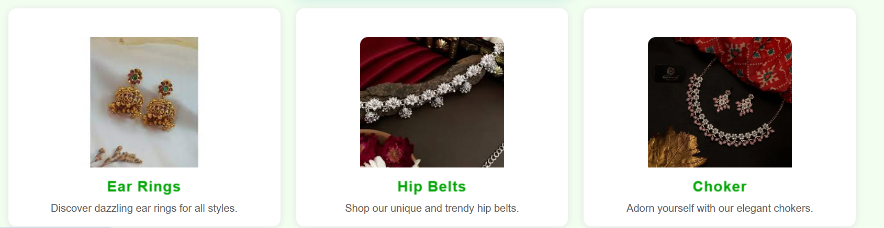
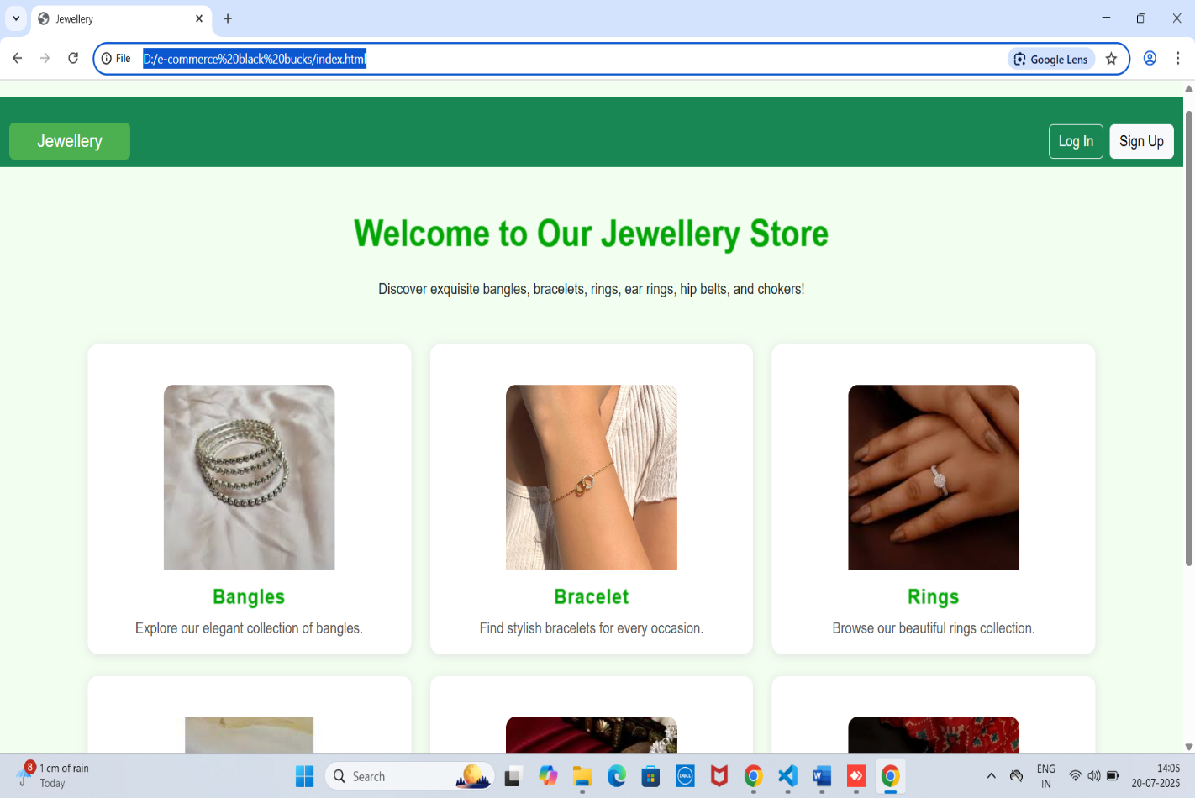

- Category Pages (Bangles, Belts etc.)

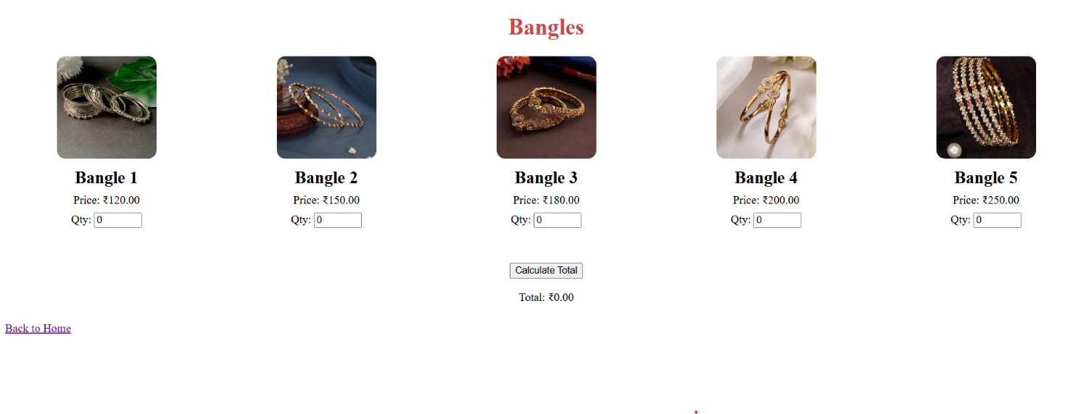
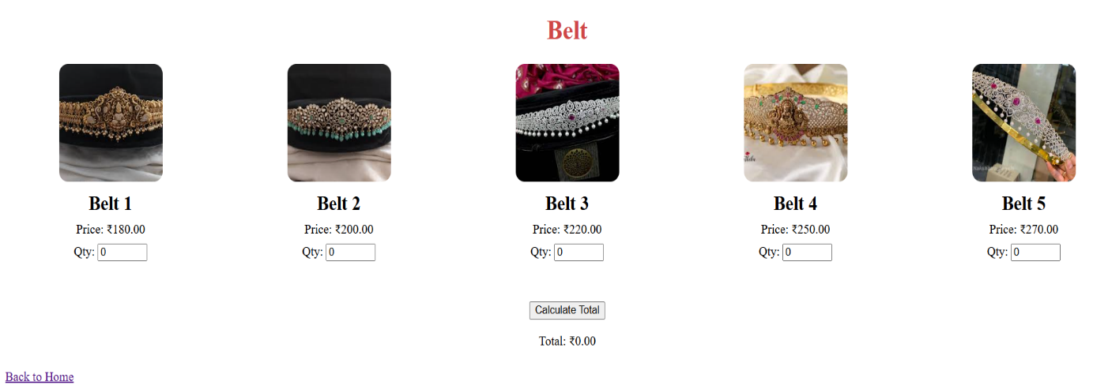

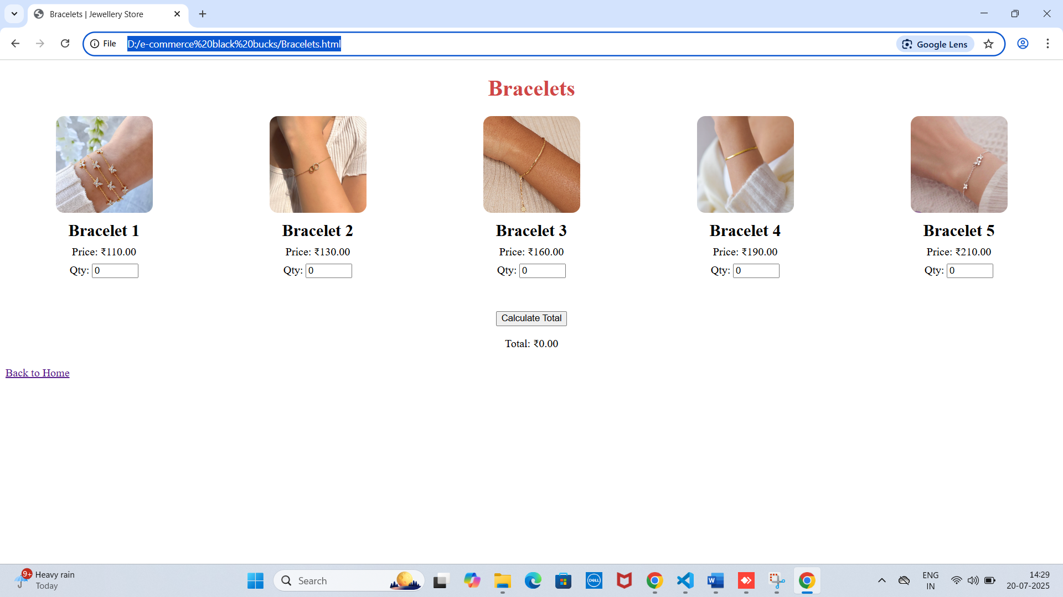

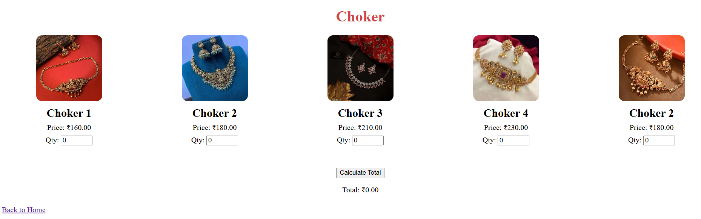

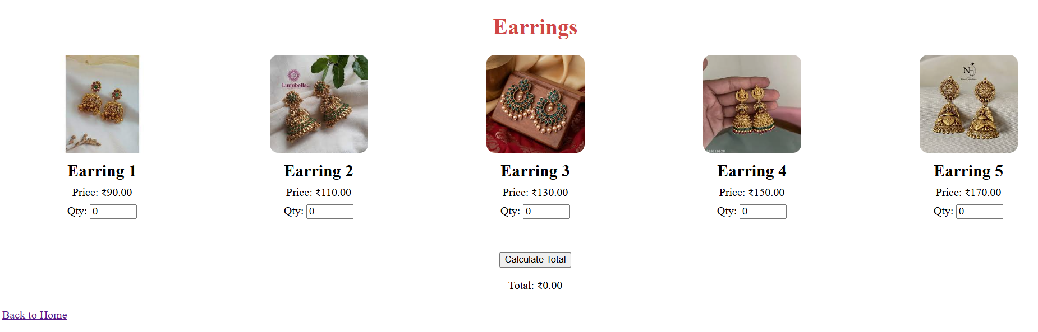

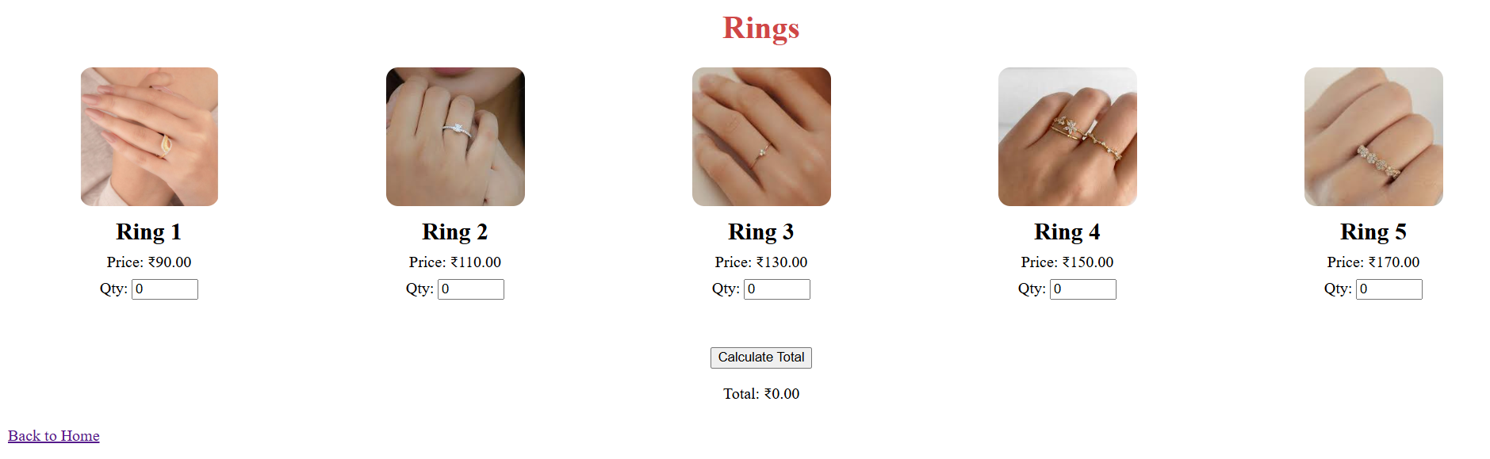

- Signin page

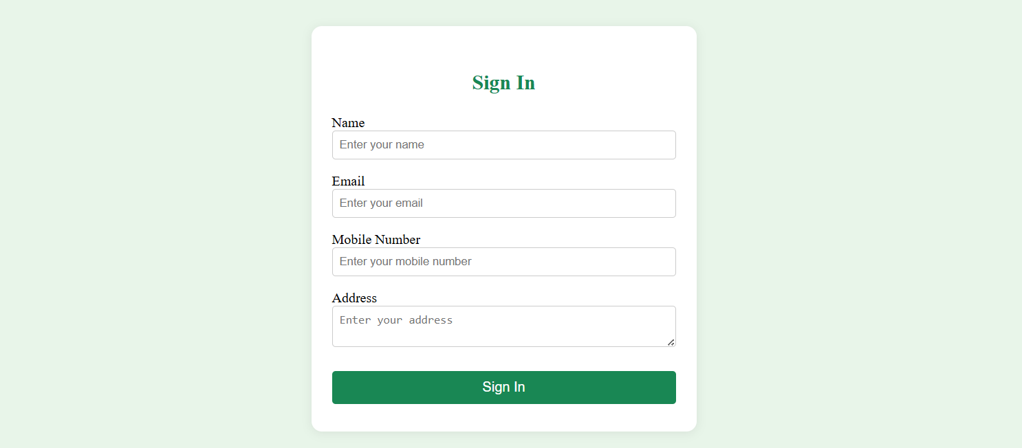

Conclusion

This project fulfills the basic requirements of a full stack e-commerce site. It demonstrates:
- Strong HTML/CSS structure
- Modular JavaScript interaction
- Good UI/UX practices
- Category-based separation of content

